A Statement of Hope, Indeed, to Fluoroquinolones’ Victims
By Savely Yurkovsky, M.D.
Re: Comments to First Post by J. King.
Dear Professor J. King, other scientists, medical professionals and all victims of fluoroquinolones,
I have learned of so many of these victims just recently, after seeing one of you in my office. Even while recognizing the gravity of this condition, I have strongly disagreed with the prevailing view of this blog: ‘no way out of this’. Yet, I hesitated to share my envisioned solution here, lest I appear as some ‘alternative opportunist’ who seeks business.
However, after this patient shared with me Professor J. King’s, ‘First Post’ on this blog, and the fact that some of these victims have committed suicide, while others are considering this, I’ve decided to speak my mind on the issue. At least between Professor King, other medical or science professionals, and participants on this blog (as Todd R. Plumb, M.D. and others), I feel that the lay people in this group will have qualified advocates who can, as I invite to, challenge my approach to fluoroquinolone poisoning.
The real subject to be addressed here, does cover, yet extends far beyond the fluoroquinolone poisoning. It includes catastrophic flaws in our medical system, the system that has produced this poison.
When President Clinton in the 90’s received an alarming report that some million Americans die annually or become severely damaged by medical treatments, his correct response was, “It must be because of a bad system, rather than just bad people.” He was absolutely correct. In fact, this year, the Scientific American journal has correctly defined our health care system as “alarmingly dysfunctional”, and likewise, concerned medical scientists and doctors throughout the years. Yet, a serious analysis of the reasons for this alarming dysfunction never occurred and, as a result, it continues to fail billions of people worldwide, and damage many, like all of you.
I will highlight only a few main flaws of this system, including alternative medicine, to better understand fluoroquinolone poisoning; otherwise we will seek its solution, as Einstein said, through the same manner of thinking that created the problem in the first place.
In short, our medicine is run through the two main manners of thinking: the mainstream conventional medicine – ‘nothing else matters in disease but drugs’ – and the opposite one, alternative medicine – ‘anything ‘natural’ is better than drugs’. Strangely enough, they both deceive themselves and the public by using and citing some formally correct scientific findings in order to justify their practice and products. However, as in the proverbial ‘forest for the trees’ analogy, they do not understand that just using published studies, correct scientific findings (in research articles, clinical trials, medical textbooks, or in ‘good idea’ type of alternative publications) in medical practice or real world, versus properly engineering these findings into scientific technology or medical treatments capable of solving chronic diseases or fluoroquinolone poisoning in individual sick humans, are completely different undertakings. Indeed, the rules of science care less about scientific findings per se, but far more about which findings to choose, ignore, combine, or run away from in order to solve a problem.
The best example of this is fluoroquinolone poisoning itself, where the application of fluoroquinolones is based on absolutely formally correct scientific findings. How many of you feel fortunate to have received fluoroquinolones as a scientific treatment? So, caution is advised when someone displays some science, and says, “Aha, that is why we have a cure for your fluoroquinolone poisoning,” or any other disease. The facts are (which I will be describing in great detail in my second book), that our entire medical education, conventional and alternative, is completely void of the knowledge of how to turn scientific findings into producing more solutions versus failures or even medical weapons, like fluoroquinolones, Accutane, and other medical bombs. Science explains such tragedies through the Law of Unintended Consequences where scientists, doctors, or bad engineers, fix one problem to only create a dozen worse ones, in the end.
I started smelling this “rat” in medical science many years ago while trying to heal my sick child, and offer something better to my patients too, rather than just pulling at conventional or ‘natural’-alternative medical straws. Each time I saw these fail, I would toss different fixes and methods. Some 30 years later, I see on this blog the same naïve fixes being offered as a “solution” to fluoroquinolone poisoning.
Surprisingly, physicists, aerospace, computer, and other engineers in our thriving technologies also use scientific findings, but why are these schools of science so successful? It is because, they are taught how to choose the necessary scientific findings and how to discern the irrelevant, unreliable and potentially dangerous ones. They first examine an entire warehouse of science (versus doctors or drug companies looking only at their own narrow specialty), with tens of thousands of parts or scientific findings, yet, they follow sound guidelines for selecting, assembling/engineering these in the most productive way. This is because they were taught real science of sound engineering, e.g., turning parts into reliable technology, or machines. In medicine this science of engineering has never, and still does not exist.
Just to offer some practical feel for this absence, do you know that when Thomas Edison faced only 100 materials to engineer just the correct 5 of these into a working light bulb, he faced 125 million wrong combinations?
In chronic diseases formally relevant scientific findings run in the tens of thousands, and their combined relationships or all possible guesses concerning potential cures for chronic diseases can run in the billions! Fluoroquinolone poisoning alone can yield hundreds of abnormal medical findings in the body, and their secondary or domino-like pathological consequences in the thousands. Which of these do we treat, which are ignored, and how do we determine effective treatment? Where is the exact formula for engineering here? The sobering truth is, as an acquaintance of mine, MIT physics professor, George Pugh Ph. D., stated in his book, ‘In complex systems (including the human body) there is no exact formula for engineering that exists.’ This means, make the best educated guess you can to hopefully arrive at an exact blueprint or theory for a proposed solution, in order to solve a problem. Or, as Nobel Laureate Dr. Peter Medawar said, “No attempt to solve a scientific problem can even be begun without the subsidy of some theory.” Also, as noted by Harvard biology Professor, Eugene Wilson (author, Consilience, the Unity of Knowledge):
“Nothing in science – nothing in life, for that matter – makes sense without theory. It is our nature to put all knowledge into context …”
Pay attention to ‘all knowledge’, because in medicine, this goes far beyond medical training.
An effective theory must answer:
- Which relevant to fluoroquinolones findings we address or ignore.
- The best diagnostic test we choose to determine this with.
- The most effective therapeutic means to resolve fluoroquinolone pathology.
As importantly, this theory must not fail other sound, scientific knowledge, otherwise it will either fail or harm.
It is obvious that conventional medicine theory – to solve medical problems through more drugs – is a poor theory, because fluoroquinolone poisoning cannot be reversed through production of anti-side effects drugs. And alternative medicine uses a virtual machine gun ‘theory’ or using anything in sight, whether related to mitochondria inflammation, or anything else through alleged ‘detoxes’, ‘chelators’, ‘oxygenators’, ‘metabolic or energetic balancers’, etc. Yet, the facts are, these all have already failed in all serious chronic diseases, including fluoroquinolone poisoning.
Speaking of ‘revitalizing mitochondria’ fixes, what is the actual success rate of this in autistic children being evaluated by truly legitimate scientific tests, followed by treatments administered at some research institutes staffed with high ranking conventional specialists and molecular scientists from prestigious medical schools? It is zero. Why? For the same reasons ‘natural’ fixes are zero, because of being based on a crippled theory, or manner of thinking, that chronic diseases can be resolved through biochemical-pharmaceutical treatments.
That is why I do agree with Professor J. King’s advice:
“And please save your money, there is no supplement, treatment, cryo, detox, ozone, hyperbolic, flush, vitamin, nutrient, infusion, injection, patch, filter, organic compound, puncture or holistic method that will correct and reverse the damage.”

“It is not my desire to be so hopeless in my posting, but we have to face the facts and science behind the drug. There is way too much puffy fluffy garbage being posted all over the internet about fixing and reversing the damage from this drug. It is not so.”
Besides, the side effects of natural treatments are very real and common, which the industry consistently ignores and conceals.

Just recently I saw a patient who only after a few days of some “natural detox” ended up becoming an invalid for 20 years until this was reversed in just one-two treatments of mine. I have seen volumes of such cases. I did try these methods and products in my own practice in the past, but realized why they did not, and could not work, except sporadically and only in mild conditions.

However, I do strongly disagree with Professor King’s next statement: “Once poisoned, you are poisoned – bottom line.” Paradoxically, the main point of my departure, many years ago, to arrive to this disagreement today, was Professor J. King’s specialty – toxicology, the science of poisons. And because fluoroquinolone disease is an outright toxicological-poison problem, we need to understand some serious difficulties in finding solutions to toxicological problems. This will show us a bigger picture behind fluoroquinolone poisoning, in order to overcome these.

I got interested in toxicology many years ago, after observing some good medical progress, in several patients, following treatments for heavy metal toxicity. After studying toxicology textbooks, I asked myself a simple question, ‘What if all chronic diseases, severe and mild, from head to toe, and from A to Z were caused by toxicological agents or environmental pollutants?’ But, the reasons for treatments failure were diagnostic and therapeutic deficiencies of the prevailing alternative and conventional methods.

The EPA and CDC do confirm that 100% of modern population does carry over 100 toxic chemicals in their bodies, routinely, and the National Cancer Institute stated that at least 98% of all cancers are caused by environmental pollutants. Toxicological literature did document how toxicological agents invade every organ and system in the body and cause hundreds of medical problems where their descriptions are identical to the symptoms and scientific findings in all chronic diseases: neurological, vascular, immune, endocrinological, and others, for which medical doctors are only trained to give drugs. Toxicological agents do also alter DNA, RNA, and mitochondria, causing chronic diseases ranging from Alzheimer’s to infertility, impotence, depression, and from heart disease to cancer.

Yet, as Professor King correctly stated, MD’s, (and alternative practitioners) have virtually no training in toxicology and, therefore, are not taught to think of diseases as states of chronic poisoning. Even if they occasionally do order some lab tests, these normally mislead them like a computer virus run program. Because:
- These often report something being in the ‘normal’, e.g., ‘safe’ range. Yet, in reality, these ranges represent bureaucratic or political smoke screens whereas such ‘norms’ or ‘safe’ levels do not even exist, because as toxicology states, one cannot have a poison in ‘safe’ levels to begin with, as one cannot give orders to an individual person to be insensitive to any level of a poison.
- Toxicology states that whatever a single chemical level might be in the body, or our environment, just judging it by that level alone is misleading, because of its underestimated, global, toxic effects, since: “All chemicals humans are exposed to are mixtures… not isolated chemicals as studied” (Studying toxicants as single chemicals: does this strategy adequately identify neurotoxic risk? Cory-Slechta, NeuroToxicology 26 (2005) 491-510).
- 99% of some 100,000 chemicals that we are exposed to daily have never been tested for safety, and even if a few tested as benign these can enter into mutual reactions inside body (and environment) with other chemicals or drugs. This creates unpredictable or chaotic consequences which the EPA, CDC, FDA, or any drug company or scientist could possibly know of, or warn us about.
Among these unpredictable reactions are: synergistic where chemicals mutually enhance one another’s toxicity, antagonistic or mutually blocking, potentiating or causing gigantic toxic effects far exceeding one of each single substance. If chemical-A toxicity has been graded as ‘2’, chemical-B as ‘3’, yet if they potentize one another their combined toxic effect on the body is not 5, but could be 20, 40, 60, or higher.

Fluoroquinolones, besides being very toxic substances on their own, can have their poisoning capability potentized or greatly enhanced to even much higher intensity by other toxic agents, contained in the bodies of modern populations.

- Among the numerous chemicals residing in the body there might be just one that plays the role of a key toxin, such as mercury – the most common poison of all – that can block effective release or metabolism of other chemicals or drugs, like fluoroquinolones.

- There are, also, the serious obstacles to conventional and alternative biochemical-pharmaceutical approaches to successfully treat toxic substances. Among these:

- None of the conventional lab tests, e.g., blood, urine, hair, and fat biopsies, can establish the presence of toxicological agents where it counts the most – in the internal organs themselves. While all of these tests may show some or no poison present, internal organs may contain high or clinically sufficient levels to cause any disease, from neurological damage to cancer.

- The internal organs often contain other poisons undetected by lab tests. Only during autopsies or organ biopsies can the poisons be established, but either test is, obviously, impractical. Besides, these tests never get ordered because conventional doctors simply do not seek toxicological screening in chronic diseases.

- The lab tests cannot tell which, out of the several detected poisons, is a key toxin or poison that deserves the foremost therapeutic priority.

Just from these diagnostic limitations alone, the entire fluoroquinolone poisoned population has ended up in some ‘black hole’, because no one knows which exact organs and how many systems have been hit. If one is to rely on the drug companies’ ‘research’ information to answer this, one might just as well resort to horoscopes. This is because they truly do not know this information themselves, due to the limitations of their bio-chemical approaches to human beings, who have hundred(s) of other poisons in the body, unlike lab mice that have few or none. Also, their safety ‘research’ data is often forged; otherwise, the drugs would hardly see the marketplace.

- Strictly speaking, there are no effective pharmaceuticals – drug or ‘natural’ – detoxifiers of toxicological agents or drugs, including fluoroquinolones.
- Because of the absence of reliable diagnostic lab methods all prevailing detoxifying therapeutic interventions not only are all doomed to hit a dead end but, often cause harm. This is because of the two main reasons:
- If one cannot tell if a poison is present or has been removed from the internal organs, how does one know when the end of a treatment even is? Does one need just 5 treatments or 500 in order to complete the detox?
Pose this question to ‘mitochondria detox’ activists.
- If one does not know how much of a poison has been mobilized by a detoxifying agent into the blood stream, initially, from some organs, how does one know if a poison ended up being dumped back into the same or being shifted into other internal organs, such as brain, heart or bone marrow, with the latter being filled with valuable stem cells?
The truth is one cannot tell through these methods, and that is why this prevailing ‘natural’ agenda with ‘detoxes’, ‘chelators’, ‘balancers’, ‘restorers’ whether of mercury, lead, mitochondria or whatever else, is not only one big fairy tale but a reckless and dangerous game of Russian Roulette. The same holds true for chelators or detoxifiers of drug companies. I realized this first hand many years ago, when a patient became very ill following chelation detox for a legitimately positive lab mercury level. He wasn’t just sick for a few days, but for a good month by the time he returned for a next visit. I tried to correct this, but I did not see him again and do not know if it worked or not. Usually, bio-chemical pharmaceutical treatments cannot correct such side effects and even if the symptoms diminish, the damage remains.

This and many other observations made me realize that all conventional and alternative bio-chemical/pharmaceutical treatments are practiced completely blindly and, therefore, are ineffective and potentially dangerous. (To assume that all energy related alternative medical modalities, per se, are effective and safe is another delusion, which is another subject). Since that incident I have seen, over the years, hundreds of victims of such treatments, from alternative practitioners or ‘natural recipes’.

Fortunately, due to the bio-energetic medical method explained here, I was able to help these victims. Below is a recent example, out of many.

Dear Dr. Yurkovsky, July 11, 2012

My son Gregory is now 11 yrs. old. Since age 3 my husband and I have been trying to help him recover from a diagnosis of autism. For 3 ½ years we did chelation. We worked with an ND for 6 months doing suppository and oral chelation. We worked for 1 year with a DAN doctor “O” doing months of oral and one IV push of chelation, B12 shots and tons of supplements and antifungals. He would make progress and then plateau. We worked another 2 years with alternative doctor “B” doing chelation using IV’s and transdermal EDTA and DMPS as well as tons of supplements.

He progressed and then began a rapid decline. During the last 5 months of this treatment Gregory became aggressive and developed tic-like, seizure-like behavior. He would flair his legs and arms into furniture causing bruising. He would push on his thighs and legs with is fists and cause massive bruising. He would push on his thighs and legs with his fists and cause massive bruising. He would bite others and the backs of his hands. A February visit to the local hospital emergency room and being seen by 5 doctors and a child neurologist provided no answers.

Following the first FCT treatment in April this behavior dropped dramatically. Following the 2nd treatment in May these behaviors have completely abated. Gregory has been weaned off all of his supplements with the exception of his daily probiotic and is once again progressing under your care.

We are so grateful for you and the benefits of FCT.

Sincerely,

Christine Horton
Vermont
(FCT® - field control therapy, a bio-energetic medical system that I have evolved, is based on scientific principles of physics, laws of complex systems, and integrates all sound conventional and alternative medical knowledge).

It is obvious from this example of detoxification that doctor “B” has blindly stirred up a ‘wasp’s nest’ of poisons due to the lack of proper diagnostic method, and did not know how to undo this. After having done the same in my own practice, I realized years ago, that in order to find effective therapeutic solutions to poisons, one had to start with a reliable diagnostic method first. Such a method must identify and monitor any poison in any organ, non-invasively at any time and as importantly, determine the true efficacy of de-poisoning treatments by monitoring the fate of poisons in the body, following these treatments. There is only one such diagnostic approach, it exists in alternative medicine, it is called bio-resonance testing.

It is enrooted in physics and its well-known scientific concept of matter-energy duality, where all matter or substances at their deepest levels (including living cells, down to DNA) represent energy fields. These fields vibrate and are each endowed with their own natural resonant frequency that serves as the energetic ID card of all substances. This, again, holds true for the cells of any human organ and, likewise, for morbid agents which cause disease – toxicological, infectious, electromagnetic, toxic drugs such as fluoroquinolones, other antibiotics, chemotherapy, Accutane, X-rays, or any other entity.

Einstein expressed physics view on all matter as being only a visual illusion that obscures its underlying energy fields. In view of physics playing such a fundamental role in all matter and physical processes, including the human body, the Oxford University physics Professor David Deutsch predicted in the 1990’s, that medicine, as it has already been the case with many other sciences, will be swallowed by physics someday, or that its practice will be greatly enhanced by physics-based diagnostic and therapeutic methods. And that medicine must find some effective universal method to treat chronic diseases versus just following the ‘Rule of Thumb’ (e.g., pulling at straws) according to medical specialties liking.

Professor Deutsch, as a knowledgeable physicist, stressed the electromagnetic nature of the human body at its most fundamental level that actually runs our entire physiology: “Living processes in terms of molecular replicators, genes is governed by the same laws of physics as apply to non-living matter.”

The same was expressed by the former Chairman and Professor of the department of material science at Stanford University, physicist William A. Tiller, PhD, in his article: “Future Medicine Based on Controlled Energy Fields”. (Material science, not chemistry or pharmacology) ultimately determines physical properties and capabilities of any material, whether a computer chip, or human cells.

Emphasizing that the most important level of human physiology being regulated by energy fields of cells of the internal organs and energy fields of molecules of body chemistry, he postulated that energetic diagnostic and therapeutic modalities such as, correspondingly, bio-resonance testing and homeopathy, among other, would play a primary role in medicine.

Besides, many other renowned scientists stressed that the human body is a known excellent generator, conductor, processor and reflector of electromagnetic energy and information.

“Energetic signaling mechanisms such as electromagnetic frequencies are a hundred times more efficient in relaying environmental information than physical or chemical signals such as hormones, neurotransmitters, growth factors, etc.”
McClare, C.W.F., biophysicist, Oxford University [1974]
Resonance in Bioenergetics, The Annals of the New York Academy of Sciences, 227:74-97.
“Body chemistry is governed by quantum fields.”
Professor Murray Gell-Mann, Nobel Prize laureate in physics
“DNA induces electromagnetic waves in water.”

In ‘DNA between Physics and Biology’
The presentation in Lindau, 28 June 2010
Luc Montagnier, PhD., Nobel Prize laureate in medicine
“The mechanism of heredity is founded on the very basis of quantum theory.”

Ervin Schrodinger,PhD.
Nobel Prize laureate in physics
“The molecules and atoms, including the ones which make up cells of human organs, bond each other or held together by electromagnetic forces.”

The Sciences an Integrated Approach
By Professor James Trefil, Ph.D., (Stanford University scholar and a contributor to the National Science Education Standards) and by Professor Robert Hazen, Ph.D., (Harvard University and Cambridge University scholar.)
“Treating humans without concept of energy is treating dead matter.”
Dr. Albert Szent-Gyorgyï, biochemist, Nobel Laureate in medicine.
However, without having a formal medical education, neither Professor Deutsch nor Professor Tiller could tell how exactly to successfully apply different energetic medical modalities into medical practice. My decades’ long collaboration with Professor Tiller helped me to carry out his prediction to successful fruition in medical practice, as I have documented many reversals and regressions of serious chronic diseases, including cancer, achieved through Field Control Therapy and based on effective de-poisoning.
One of the bio-resonance testing methods mentioned by Professor Tiller, that I utilize to identify the aforementioned resonant ID signatures of the internal organs, and their poisons, is a simple muscle test – applied kinesiology.
The practical vantage point when testing for fluoroquinolone poisoning, or in any disease, is that its skillful use allows for non-invasive, energetic penetration of any organ in the body, while screening it for fluoroquinolones or other morbid agents. The latter may potentize fluoroquinolones or block their release from the body. Likewise, one can detect and follow through on the residues of fluoroquinolones in multiple organs, following treatment. This can also help us to logically conclude, when some of the symptoms might still persist, if these are due to the fact that there are other poisons playing the role too, and not necessarily the assumed permanent damage by fluoroquinolones, or because fluoroquinolones still remain in certain organs and continue causing damage. Under either circumstance, better and more appropriate therapeutic decisions can be made.
Nobel Laureate in medicine, Professor Montagnier, utilizing bioresonance testing with a different method, has registered even extremely fine nanostructures of bacterial DNA through tracing their electromagnetic signals in biological material. He credited this to the aforementioned resonance phenomenon in physics as utilized by other bio-resonance tests, including applied kinesiology. (“Electromagnetic signals produced by Aqueous Nanostructures Derived from Bacterial DNA Sequences” Luc Montagnier, et al., Interdiscip Sci Comput Life Sci (2009) 1: 81-90).
Here is only a sample of documented cases from my practice which attest to the accuracy of applied kinesiology.
This patient, a medical scientist himself, developed severe delusional schizophrenia immediately following insertion of mercury amalgam fillings. Yet, following removal of presumably all of his mercury fillings, old and new, he remained ill by the time of his first visit to my office.
Applied kinesiology test indicated ill effects of nickel and mercury on his brain and, also, concealed mercury amalgam filling in one of his teeth. This could not be possibly visualized as one can tell from his report.
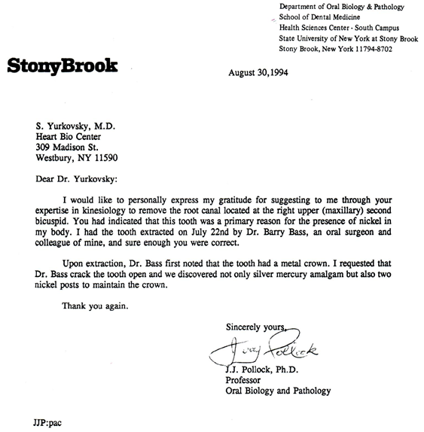

- Another confirmation from dental practice where x-ray validated applied kinesiology finding of residues of mercury filling that was covered with the new filling, on top of it.
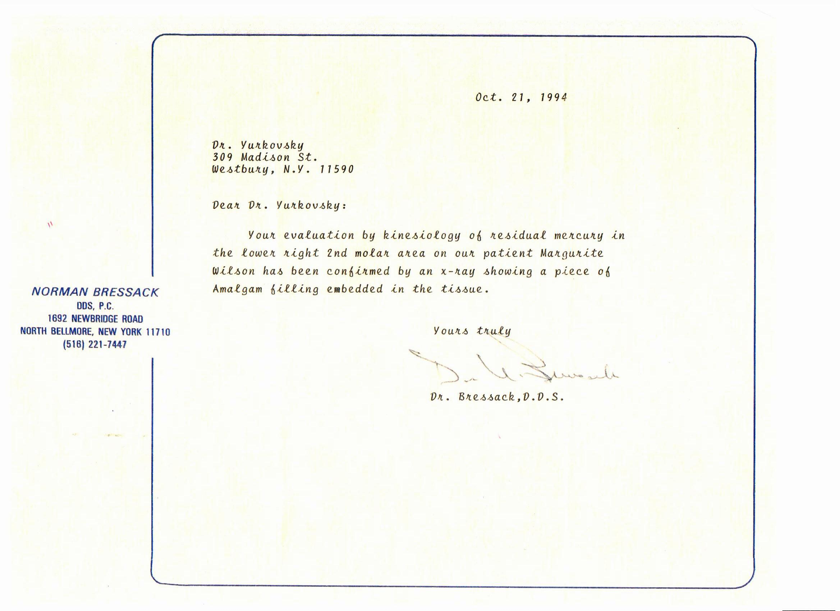
A mathematical analysis indicates that a probability of correct determination in these two dental cases by chance alone is 1:10,000.

- Toxicological assessment of lamb liver, and allegedly organic from pristine New Zealand, consumed on a regular basis by an autistic boy, a patient of mine. My bio-resonance, applied kinesiology testing has indicated that it was contaminated with toxic metals. This toxicological analysis does confirm the presence of toxic metals: cadmium and copper.
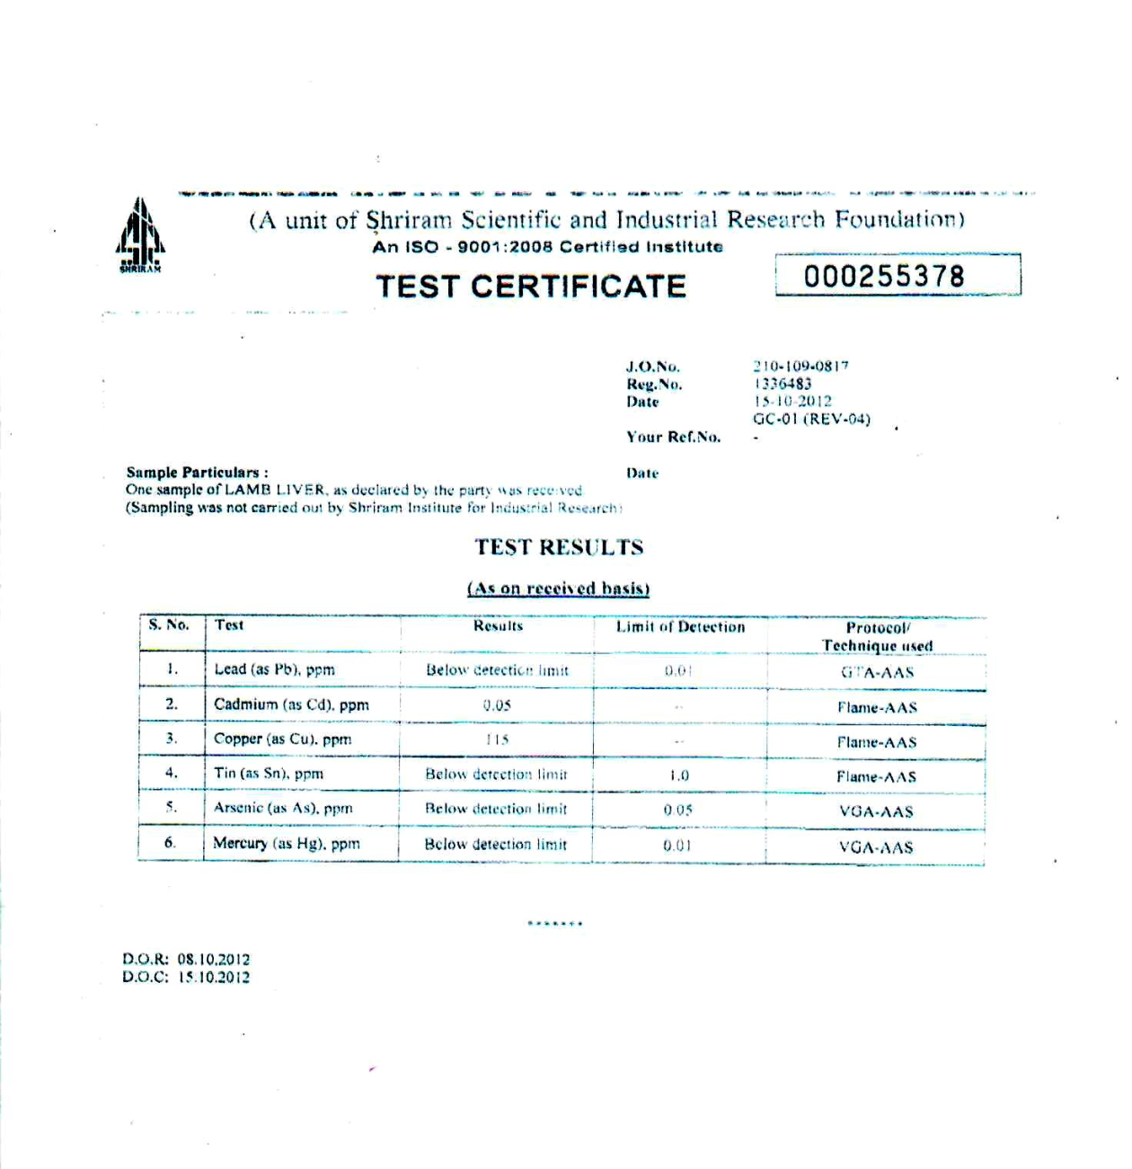
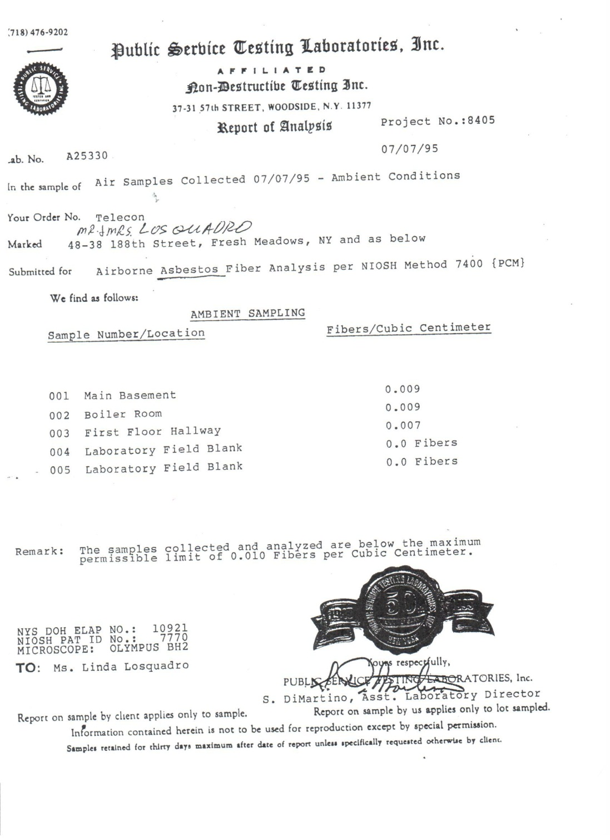
- A teenager with ADHD was also diagnosed through my bioresonance testing as having asbestos in his lungs that might lead to lung cancer in the future. An inspection of his and his parents’ house has confirmed the test findings, even as the level of asbestos present was reported as quite low.

- 10 month old toddler treated by me for severe disfiguring total body dermatitis. Bioresonance testing found mercury in his skin, gastrointestinal tract, liver, and other organs. The testing revealed extreme stress reaction against a sample of his mother’s breast milk which, in its turn, tested as energetically eliciting severe muscle stress reaction by the boy, suggesting mercury was present in his mother’s breast milk. This report of her breast milk confirmed this with high mercury level being present which the boy was consuming on a daily basis.

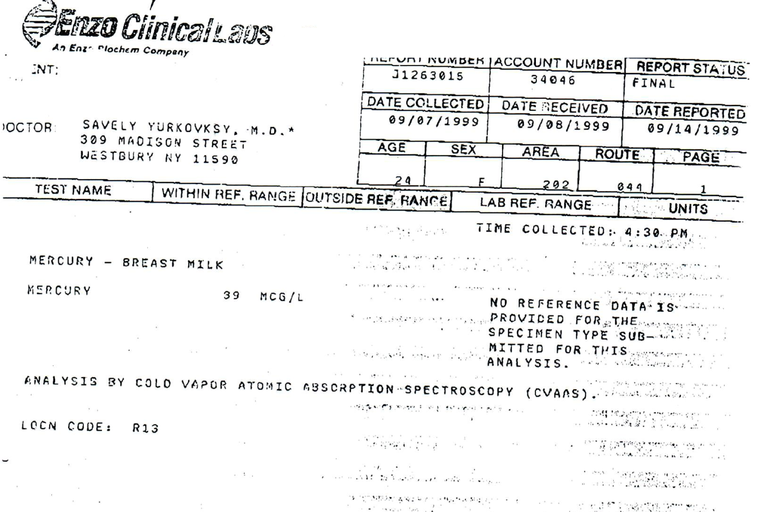

Therapeutic means to address fluoroquinolone poisoning – homeopathy & causative homeopathy – and their scientific principles

- Scientific literature has confirmed that the human body is highly attuned and responsive to energetic information contained in homeopathic remedies, as attested by these scientific references, among many other:
“Are the Clinical Effects of Homeopathy Placebo Effects? A Meta-analysis of Placebo-Controlled Trials,” Linde, et al., Lancet, September 20, 1997, 350: 834-843.
“Clinical trials of homeopathy.” Kleijnen, et al., (1991) British Medical journal; 302: 316-323.
In addition to clinical trials, several hundred basic science studies have confirmed the biological activity of homeopathic medicines.
Some of the most recent confirmations came from the scientists at the prestigious Indian Institute of Technology (Chikramane PS, et al. Extreme homeopathic dilutions retain starting materials: A nano particulate perspective. Homeopathy, volume 99, Issue 4, October 2010, 231-242), and the premiere cancer research institute in the U.S., – University of Texas M.D. Anderson Center — registered homeopathic effect even as deep as at gene level and verified homeopathic biological effects as destroying even cancerous cells (Cytotoxic effects of ultra-diluted remedies on breast cancer cells, Moshe Frenkel, et al., International Journal of Oncology 36: 395-403, 2010).
Among other high level scientific confirmations, is the recent research of aforementioned Nobel Laureate in medicine, prof. Montagnier on bacterial DNA, using homeopathic solutions. He has voiced his support for biological action of homeopathy, in response to allopathic skeptics, in his recent interview in Science magazine of December, 2012. (Luc Montagnier, Nobel Prize Winner, Takes homeopathy seriously, http://www.huffingtonpost.com/dana-ullman/luc-montagnier-homeopathy-taken-seriously__b_814619.html).
Another Nobel Laureate and world renowned British physicist from Cambridge University, Professor Brian D. Josephson referred to rejections of homeopathy, which are based on the well-known scientific limitations of chemistry and pharmacology, as ‘dogma’ and ‘simple-minded analysis’. He submitted more fundamental scientific evidence in support of homeopathy (Brian D. Josephson, Emeritus Professor of Physics: ‘Liquid crystals contradict the idea that Liquids cannot have Ordered Structures’ (http://homeopathyheals.me.uk/site/featured/2612 –brian-d-josephson-emeritus –professor-of -liquid-crystals-contradict-the-idea-that-liquids-cannot-have-ordered-structures-).
Prof. Josephson stated that scientific nature of homeopathic remedies was further buttressed by a recent Nobel Prize discovery in chemistry (besides physics) by Dr. Daniel Shechtman, based on identifying quasicrystals in solutions. Prof. Josephson also mentioned that as the case is still with critique of homeopathy, Dr. Schechtman’s research prior to its winning Nobel prize, was lambasted by certain ‘science experts’ for ‘bringing disgrace’ on himself and his research group. Among other scientists, Professor of materials science at Penn State University, Rustum Roy, Ph.D., and co-authors submitted a research study substantiating scientific basis of homeopathic solutions, based on the physics branch of materials science. (The Structure of Liquid Water; Novel Insights From Materials Research; Potential Relevance To Homeopathy. Rustum Roy,et al., Materials Resarch Innovation 9-4: 1433-075X)
- Homeopathic remedies as no other therapeutics are highly versatile and specific as these offer highly energy specific signals prepared from any causative agent of disease. This is because the preparation can involve any morbid cause of disease — toxicological, infectious, nuclear, toxic drug, or any other agent. The same holds true for any member of fluoroquinolones. Clinically, this means that homeopathic fluoroquinolones, while not containing even a single molecule of the drugs, would deliver a specific, e.g., fluoroquinolone energetic ID signal to stimulate the body’s metabolic system to start releasing/metabolizing fluoroquinolones.
- Homeopathics, unlike drugs and supplements which, usually, are not only more costly, but because of being ineffective in chronic diseases, need to be taken continually, with practically no end point in sight.
- Scientific research has also confirmed effective biological action of homeopathic preparations, specifically, in relation to toxicological and other morbid agents, including toxic drugs, as illustrated below.
Documented efficacy of homeopathic isodes* and remedies through scientific research
1) Ability to successfully detoxify toxic metals and heavy metals:  Arsenic  Bismuth  Cadmium  Copper  Lead  Mercury | 2) Ability to successfully detoxify chemicals:  Alloxan  Carcinogenic substances  Mustard gas  Pesticides  Tetrachloride
3) Ability to successfully detoxify other poisons:  Ionizing radiation  Poisonous mushrooms  Poisonous plants  Snake venom  Toxic drugs | 4) Ability to successfully treat or prevent infectious diseases and epidemics:
 | Cholera  Diphtheria  Leptospirosis  Lyme Disease  Malarai  Meningitis | Plague  Polio  Scarlet fever  Smallpox  Tularemia  Typhus
*Isode is a homeopathic remedy that was prepared from a specific noxious agent – toxicological, infectious, drug, or any other.
This is the reason I have named this type of homeopathic applications – Causative Homeopathy – emphasizing its ability to turn the body’s defenses against actual causes of diseases or poisons residing in the body or which threaten it in the environment. Causative homeopathy is truly based on valuable contemporary medical knowledge from toxicology, immunology, infectious diseases, and other, has proven to be far superior to other types of homeopathy, or any other medical modality, conventional or alternative, in practically all chronic diseases.
Scientific research has also documented the ability of homeopathic remedies to restore damaged organ function.
One of the most impressive and recent largest homeopathic clinical studies of 2.3 million people, conducted by the Cuban equivalent of the American NIH, involving conventional immunologists and infectious disease specialists, has confirmed causative homeopathy principle – therapeutic cause cures or prevents the cause of disease. Homeopathic vaccination prepared from the actual leptospirosis bacteria, against lethal infectious epidemic of leptospirosis, fared even more effective than a conventional leptospirosis vaccine, while also being ten times cheaper (Bracho G et al., Large-scale application of highly-diluted bacteria for Leptospirosis epidemic control, Homeopathy 2010; 99: 156-166.)
Yet, several conventional medical peer-reviewed journals helped, again, to keep the mainstream medical professionals and scientists in the dark, to the utter detriment of our healthcare and the public, by refusing to publish this study even without finding it scientifically flawed.

A few clinical examples from my practice concerning the use of causative homeopathy in severe toxicities
- The following is a statement of the former Ground Zero worker, the FDNY’s Fire Marshal, at the time.
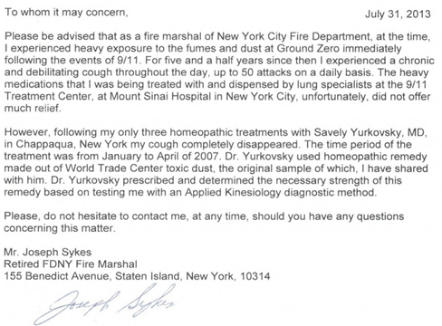
- Another statement from an even more severely ill Ground Zero victim:
To Whom It May Concern,
I am a nurse who worked at a hospital right near the World Trade Center on 9/11/2001. As a result, following the attack, I gradually sustained such severe lung damage that I could barely walk a half-block’s distance, suffered from debilitating fatigue and was eventually placed on a lung transplant list at Mt. Sinai hospital in Manhattan.
My lung function continued to deteriorate over the years, despite the medications I had received from my lung specialists at the hospital. That was until I started taking a homeopathic treatment as prescribed by Savely Yurkovsky, M.D. in Chappaqua, NY, as of 2007. Shortly following this, my fatigue was gone, my energy and lifestyle have returned to normal and I was able to walk, and still do walk, 15 city blocks.
As of approximately 2009, I was removed from the lung transplant list by my lung specialists.
Sincerely,
BB RN
Manhattan, NY
- Speaking of ionizing radiation exposure that can induce the same DNA damage as fluoroquinolones, as stated by Professor King. A testimonial from a patient of
mine, Oscar winner for her documentary, Chernobyl Heart.
“I have visited the Chernobyl area numerous times during my network assignment. Each time I was diagnosed with the radiation illness and fell very ill. Each time homeopathic nuclear radiation vaccine led me to a prompt recovery.”
Maryann DeLeo, film director, January, 2003

- A statement from a patient of mine who I have treated for nuclear fallout following the recent Fukushima disaster:
To Whom It May Concern,

Following the Fukushima, Japan nuclear disaster in March, 2011, I have developed a number of debilitating medical problems, while living in Glasgow, Scotland. Health officials there did confirm the presence of ionizing radiation in the area.
However, within weeks following homeopathic treatment for nuclear radiation, as prescribed by Dr. Savely Yurkovsky of Chappaqua, NY, USA, all of these medical problems ceased and did not return.

Sincerely,
OB
European Union

- Here is a recent case with severe neurological problems as the result of conventional drug poisoning.
To Whom It May Concern,
In the summer of 2013, I started consuming a medication called Haloperidol which was prescribed by a prominent medical specialist from a prestigious medical school clinic, specializing in taste and smell disorders. Shortly following the administration of this drug I have developed severe neurological symptoms: severe facial tremors and distortions, slurred speech, intense mouth twitching which caused me to bite and injure my tongue, stuttering, arm tremors, chest and back twitches, and insomnia.
All of these were becoming progressively worse until I went to see Dr. Yurkovsky, in Chappaqua, NY. He tested me with bio-resonance testing that suggested that I had residuals of Haloperidol and mercury in my cerebra-spinal fluid, and other regions of my brain. Following his homeopathic treatment, which I took for only several days, all of my neurological problems have completely disappeared, and have never returned.

Sincerely,
JK
I have treated with this bio-energetic diagnostic/therapeutic system people who were disabled or severely incapacitated from multiple chemical sensitivities, some from working at a chemical factory, others from just our daily, including medical, toxic sources. Yet, all of these people have completely recovered, are back to work, and have an unhampered lifestyle.
Is there a good reason why this system would not work for fluoroquinolone poisoning? Indeed, for many years I have not had any problems treating one of the toxic fluoroquinolone residues – Cipro – with homeopathic Cipro without encountering any side effects, but only benefits to patients.
Numerous scientific references in support of this medical system are also listed in my first book. These refer to:
Electromagnetic principles of human physiology – ref. 30 – 81
Bio-resonance diagnosis – ref. 254-297
Scientific principles and clinical studies concerning homeopathy – Ref. 81-142, 153- 177
Scientific studies with homeopathic remedies to detoxify toxicological agents and ionizing radiation – ref. 178-231
Scientific studies and historical data concerning homeopathic effectiveness against infectious diseases and epidemics – ref. 154-177

The scientific principles based on physics in support of bio-resonance testing and homeopathy, as presented in my book, have been endorsed by the internationally known physicist, emeritus Professor of physics at MIT, George Edgin Pugh PhD, and former chairman of materials science at Stanford University, emeritus Professor of physics, William A. Tiller PhD.
I, in collaboration with the Department of Gastroenterology at Johns Hopkins University School of Medicine, have contributed a chapter on homeopathy and bio-resonance diagnosis to the textbook of Integrative Gastroenterology (Oxford University Press, June, 2011).
Far from jumping on a ‘band wagon’ I, thanks to bio-resonance testing, have been detecting great antibiotic-related damage to humans, for decades. This damage is logical and unavoidable under the current medical regime, simply because practically all of our genes had originated from bacteria through billions of years of evolution, from simple life forms when bacteria and viruses kept merging into more complex organisms and our mitochondria cells still carry bacterial remnants. Not surprisingly, some forms of cancer (breast cancer in women, and likely many others too) have been correlated with the frequency of antibiotics use. That is why from, at least the end of 90’s, I have never used a single antibiotic even while treating all sorts of infections, from pneumonia to Lyme.
Certainly, it was only the matter of time, as the medical scientific ignorance of medical doctors training would force them to resort to the use of exponentially stronger and toxic antibiotics like, quoting Professor King, an atomic bomb of fluoroquinolones. Certainly, more atomic bombs are on the way simply because they automatically lead to bacterial resistance, which needs more and stronger bombs to overcome it.
While all of the pertinent scientific data concerning this damage is certainly very important, including possible DNA damage in some, yet, it is a big mistake to view each quinolone victim as some isolated petri dish that is filled with only quinolones alone. This is generally a fundamental mistake in all of medicine, where formally correct scientific data, at surface value, overshadows other very important scientific information concerning additional causes of disease, all acting as a vicious complex of causes sustaining one another.
That is why a Professor Colin Alexander, MD, stated in his recent book, Complexity & Medicine, that, medicine has failed to conquer chronic diseases because it focuses on scientific findings while overlooking their causes which are, often, more than just one.
Because the internal terrain of each sick and ‘healthy’ person is very complex and individual as well as his/her environment and lifestyle, our bodies contain and are influenced by many other morbid factors which play a significant role in how one could respond to quinolones or anything else, even a vitamin pill. That is why I can fully relate to another valid point Professor King made, concerning quinolones: “Why do some people who take the quinolones have little side effects, while others are blown away? Answer: It has to do with two obscure liver enzymes that metabolize the quinolones and thus minimizing their DNA-Adduct actions.”
These two enzymes, which Professor King had tested as extremely low in his blood tests, are Cytochrome P450 (primarily contained in the liver) and CYC (SCC) plus Endothelin. Is it possible that quinolones just by themselves sank these important detoxifying enzymes? Yes, quite possible, yet complexity asks more and deeper questions – what if these enzymes have been already pre-sank by environmental pollutants such as pesticides, arsenic, mercury, herbicides, other, and their combinations?
What if our staggering level of electromagnetic pollution that is essentially alien to our bodies, in the first place, and which has increased by some 30 million fold only over some century’s time (amounting to a second on the evolutionary scale for our genetic development and adaptation) retards excretion of these pollutants from our livers, immune system, and body in general? Professor Yuri Grigoriev, MD,
Chairman of the Russian National Committee on Non-Ionizing Radiation Protection under the Academy of Science & a member of the International Advisory Committee of World Health Organization of EMF and Health, stated that, ‘Electromagnetic fields (EMF) represent the greatest danger facing humanity today.’
Both toxicological agents and EMF have proven to cause immune suppression. These lead to chronic infectious diseases which then cause chronic inflammation, the latter being recognized as one of the key pathologies in many chronic diseases, invariably leading to chronic pain. Certainly, toxicological agents and EMF can be acting as both additional poisons and also catalysts or potentizers of quinolones, whereas quinolones were undoubtedly the last poisonous straw that broke the proverbial camel's back. Through my bio-resonance testing I have been detecting toxicological and electromagnetic fields present in everyone’s organs, over the years. A search of scientific literature confirmed this, including proof of EMF action even on the liver’s Cytochrome (CP-450), and it causing impaired drug clearance [(Effects of magnetic fields on rodent monooxygenase enzymes. Bioelectromagnetics, 1995; 16(5):324-9, Del Carratore et al.), (The effect of electromagnetic fields on the cytochrome P450 system in rat liver induced by phenobarbital. International Conference and COST 281 Workshop on Emerging EMF Technologies, Potential Sensitive Groups and Health. Graz, April 20/21, 2006. Wiaderkiewicz et al.)].
There are also plenty of scientific studies which confirm that EMF directly destroy DNA and cause cancer [(Enhancement of chemically induced reactive oxygen species production and DNA damage in human SH-SY5Y neuroblastoma cells by 872 MHz radiofrequency radiation. Mutat Res, 2009 Mar 9;662(1-2):54-9. Doi:10.1016/j.mrfmmm.2008.12.005 Epub 2008 Dec 24. Luukkonen J., et al.), (Decreased DNA repair rates and protection from heat induced apoptosis mediated by electromagnetic field exposure. Bioelectromagnetics, 2002 Feb;23(2):106-12. Robison, et al.), (Electromagnetic fields stress living cells. Blank & Goodman, Pathophysiology. 16 (2009) 71-78.)].
Moreover, there is a confirmation of more destructive effects on the body from the synergistic effects of toxicological agents and EMF: more DNA destruction, more organ dysfunction, more paralysis of the body’s key metabolic functions, including the ability to detoxify itself [(Biological effects induced by combined exposures to electromagnetic fields and chemical or physical agents: a review. Scarfi, M. ICEMB at CNR – Institute for Electromagnetic Sensing of Environment, Naples, Italy), (Do extremely low frequency magnetic fields enhance the effects of environmental carcinogens? A meta-analysis of experimental studies. Juutilainen et al., Int. J. Radiat. Biol., Vol. 82, No. 1, January 2006, pp. 1-12.)]. So the real picture, as I have already detected in my fluoroquinolone poisoned patient, is much broader than just involving fluoroquinolones alone.

From my decade’s long clinical experience, I have never encountered a single patient who had a chronic disease due to just a single morbid factor. I have never encountered a patient who had Lyme’s disease only because of Lyme bacteria, chronic fatigue only because of Epstein Barr virus, mercury toxicity only because of mercury, herpes only due to herpes virus, fungal, parasitic, or other prevalent medical condition only because of these or some other single entities present in their body.

That is why the great majority of patients, about 99%, who were treated elsewhere based on such assumptions of isolated causes of their chronic disease, have failed to be cured.

The overwhelming majority of patients who I have treated based on complex, but pertinent to their disease group’s causes, have made a remarkable recovery from even the most serious chronic diseases, with many of these being confirmed through conventional tests. All of these causes were from combined: toxicological (including medications), infectious and electromagnetic morbid agents.

Not surprisingly, when I performed bio-resonance testing on this aforementioned new patient with fluoroquinolone poisoning, fluoroquinolones were not the only problem. I found toxic metals and other organic toxicological agents such as solvents, pesticides, and other; infections and severe electromagnetic stress. These were impairing practically all organs and systems, thus, logistically enhancing fluoroquinolone toxicity and blocking their effective detoxification. Yes, the liver, among other organs, tested as poisoned by quinolones too.

A few more points against hopelessness in this tragedy:

Even though Professor J. King’s impressive data concerning DNA damage appears to be very serious, homeopathic remedies in the aforementioned recent cancer research did prove to act even at the level of genes.

Even inherited DNA mutations in humans demonstrated reversion to norm in some studies. Therefore, DNA damage, in and of itself, cannot be considered as necessarily fatal or absolutely irreversible, given the proper treatment (In vivo reversion to normal of inherited mutations in humans. Hirschhorn, J Med Genet 2003;40:721-728.).

I had used homeopathically prepared DNA in bio-resonance diagnosis for many years. Although I cannot prove its precision, except by observing much better therapeutic responses, there is no legitimate tenet in science precluding human DNA from being diagnostically screened via resonance phenomenon.

Through many years of practice with this method, often serious and advanced chronic diseases deemed as irreversible have been, indeed, reversed or significantly regressed. Whenever capable tools are able to detect, monitor, and address the cause of disease the end result and potential of such interventions carry unlimited possibilities.

I would very much invite interested parties to consider organizing a clinical study to test this method for its great potential to offer concrete help to these victims. All proper conventional testing, including DNA, are welcomed to monitor this study. In the majority of these victims I do not doubt achieving at least a tangible, if not very high, success rate.

In conclusion, science in any field utilizes two main mechanisms for its progress. One – conjectures – or novel ideas, in order to avoid stagnation, and the other – refutations – or well-established scientific knowledge to destroy invalid new ideas, in order to avoid turning itself into a collection of false knowledge. Unless one can destroy a novel idea, such as this, based on solid scientific evidence, such a novel idea, no matter how improbable or exoteric it might appear, does remain as potentially valid and, given an opportunity, may prove itself as very capable, for a fact.

Therefore, unless someone can prove through solid scientific arguments that my approach towards finding a solution for fluoroquinolone poisoning is incorrect, it must remain, at the very least, potentially valid. If the victims of fluoroquinolone poisoning have better scientifically sound options to pursue at this time, in order to literally save their lives, they should pursue them. In the absence of such options, this proposal stands as asserted.
Sincerely,

Savely Yurkovsky, MD
Chappaqua, NY

